LEZIONE 21/04 pt.1
MACHINE LEARNING for vocal analysis.
Insight into machine learning approaches for health monitoring.
The goal is projecting a system capable of monitoring our status of health.
The tools are non intended to provide a definitive diagnosis, but to help clinicians triage potential cases.
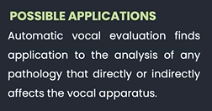
Important to understand 10/20 years earlier than manifestation of symptoms if patient is starting to develop the issue.

When a person is depressed, the voice changes. They speak at a constant amplitude and loudness, not having peaks. We can classify in sad/happy people.
We can detect respiratory diseases, because covid, for example, affects vocal apparatus.
We can analyse sleep disorder, important markers of neurodegeneration.
It is the same for eating disorders. In obesity, the amount of body-fat influences the capability to produce the sounds.
PARKINSON’S DESEASE identified by analysing acoustic features of each sustained vowel phonation.
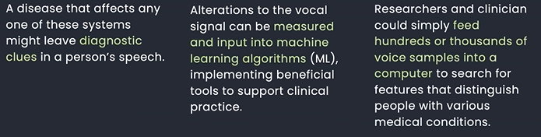
ALZHEIMER’S DESEASE: shorter words, small vocabulary, more fragmented sentences.
AUTISM SPECTRUM: analysing babbling of infants.
POST TRAUMATIC STRESS: people change their emotion, flatter and more monotonous speak.
CORONARY ANGIOGRAM.
Speaking requires the coordination of numerous anatomical structures and system.
Lungs: produce a flow that passes through the larynges and arrive to vocal cords. Can be close together or apart. If together, they produce sounds that are shaped by tongue, lips and nasal structure.
If the cords are a part, do not vibrate, the sound produced is not periodic and called unvoiced sounds (consonant).
All this is coordinated from brain.

ADVANTAGES:
- EASY COLLECTION
- USEFUL INFORMATION
- OBJECTIVE MEASURES
- LOW-COST
- REMOTE MONITORING.
The aim of the project is to develop a web /smartphone app that will be able to enhance frequent and remote monitoring of the patient’s health condition.
The app must include:
- Tailored exercise
- Personalized application
- Objective measures
- Monitoring
- Assistance
- Education.
CASE STUDY: PARKINSON’S DESEASE.
Degeneration of dopamine neurons, especially in the substantia nigra pars compacta region of the midbrain.
Progressive disability with impact on ADLs (activities of daily living).
Motor/ Non motor symptoms.
It affects 1% of over 60 population, 9 million people. 90% of them presents speech alteration, that comes out 10 years before the manifestation of the disease.
We want to:
COLLECT DATA -> EXTRACT INFORMATION -> ANALYSE DATA.
The extract information is made of:
- Pre-Processing (silence removal, de-noising, normalization, regions identification, framing)
- Feature extraction (high-level/low-level features): PHONATION, ARTICULAT, PROSODY.
- Feature selection
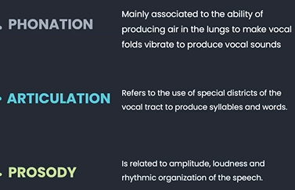
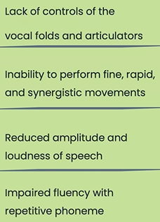
SPEECH ALTERATION IN PARKINSON’S DESEASE PATIENS.

The analyse data is made of:
- Investigate possible correlations and trends
- Perform classification
- Perform regression.
The occlusive consonant is the most affected in Italian language. (T, P). Are produced by a rapid movement that firstly blocks air behind the vocal cords and releases their positions and makes air flows between them.
.

